**Ideation Phase**

**Define the Problem Statements**

|  |  |
| --- | --- |
| Date | 22 June 2025 |
| Team ID | LTVIP2025TMID48676 |
| Project Name | Cosmetic Insights |
| Maximum Marks | 4 Marks |

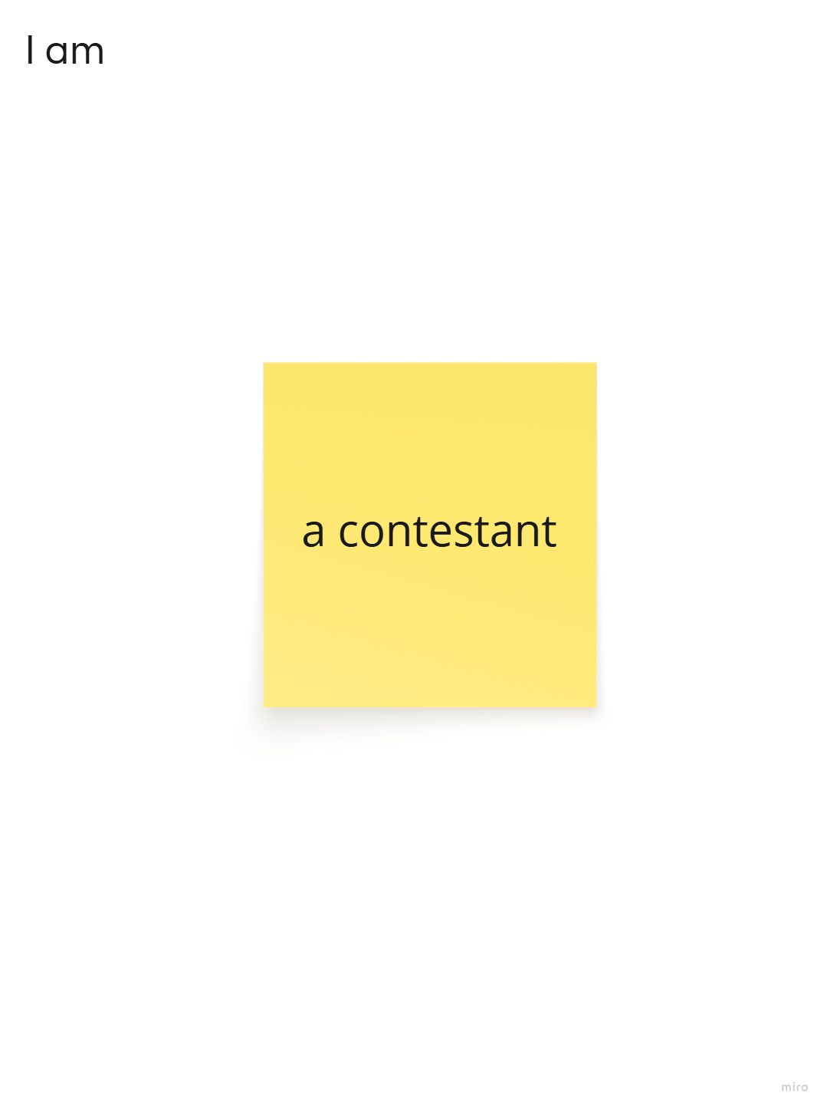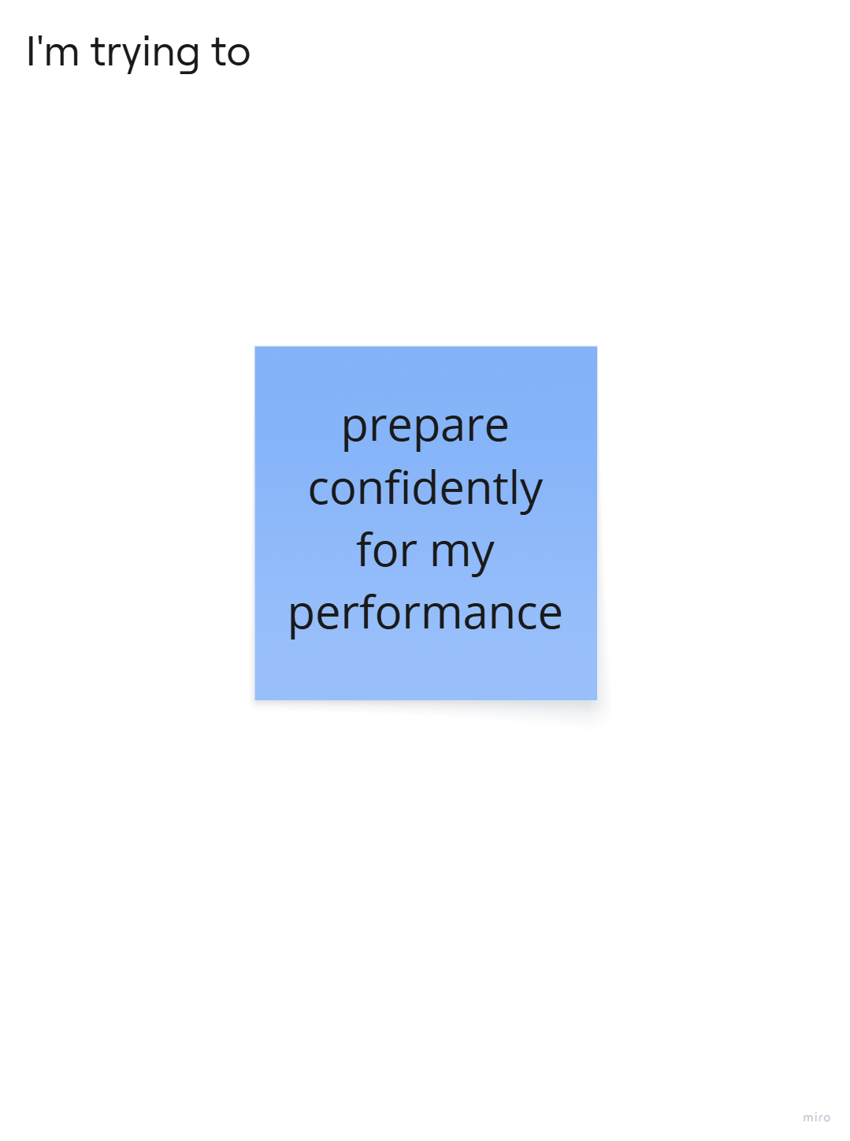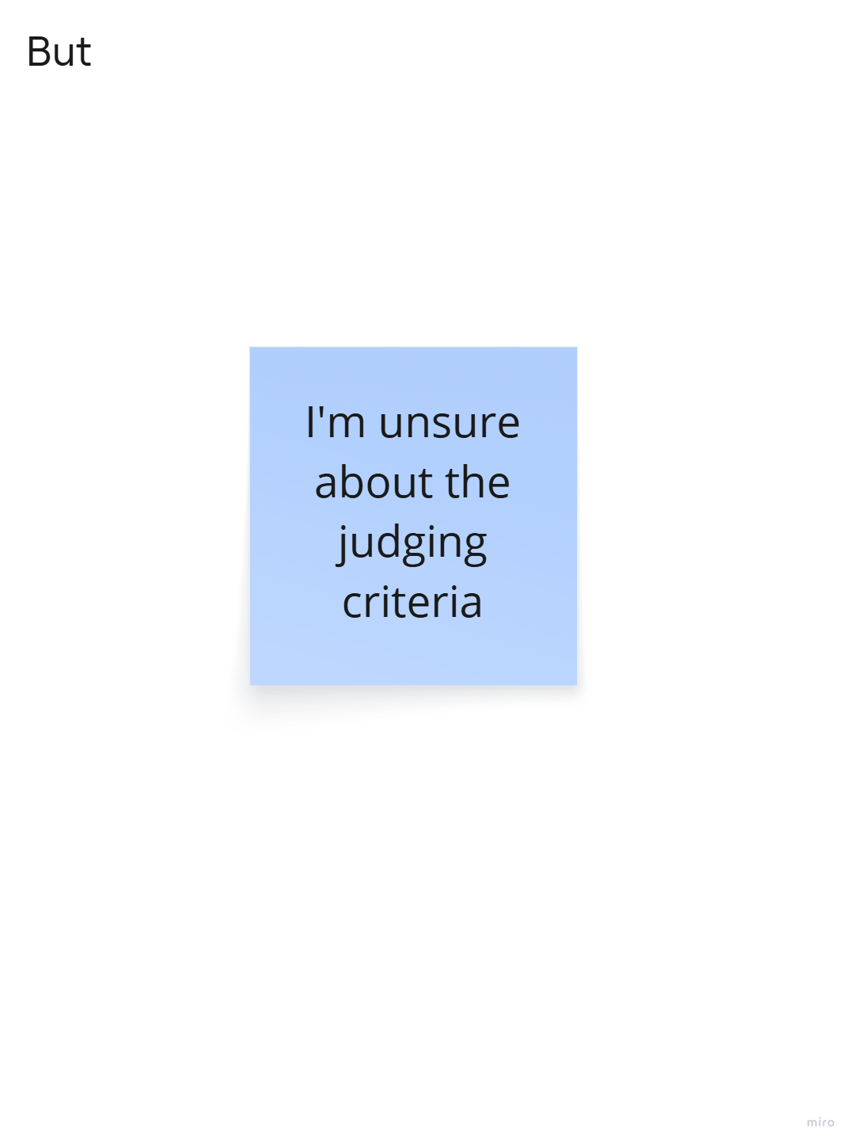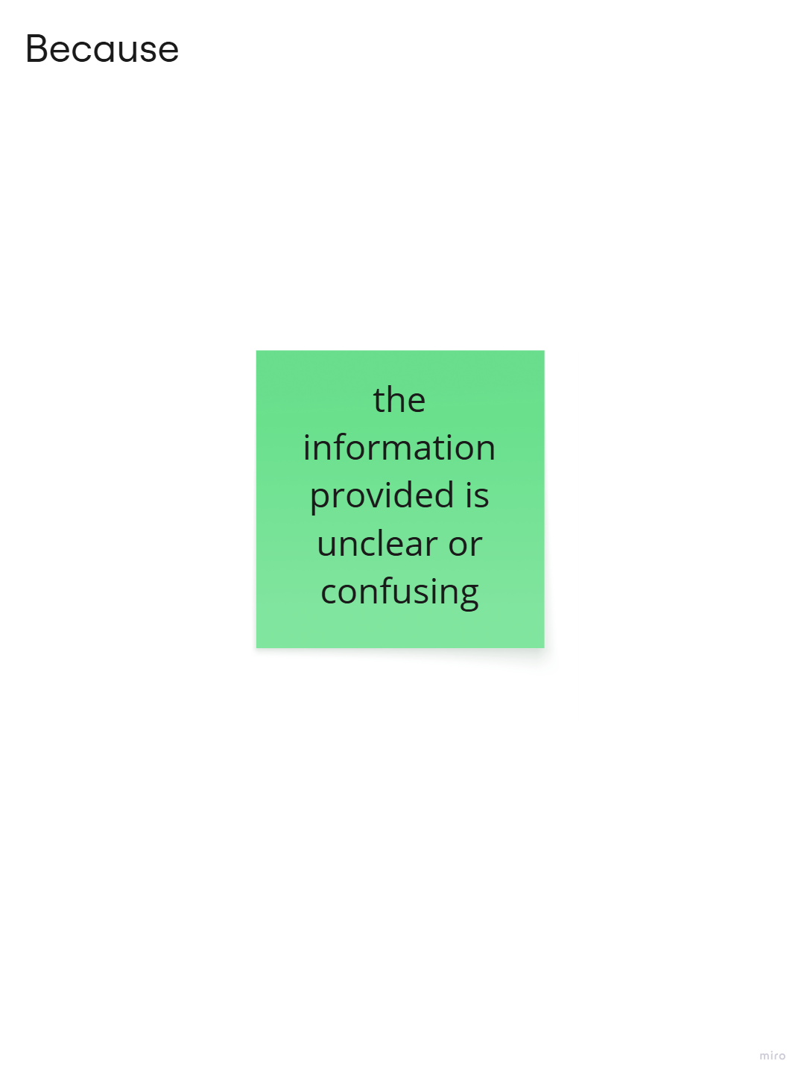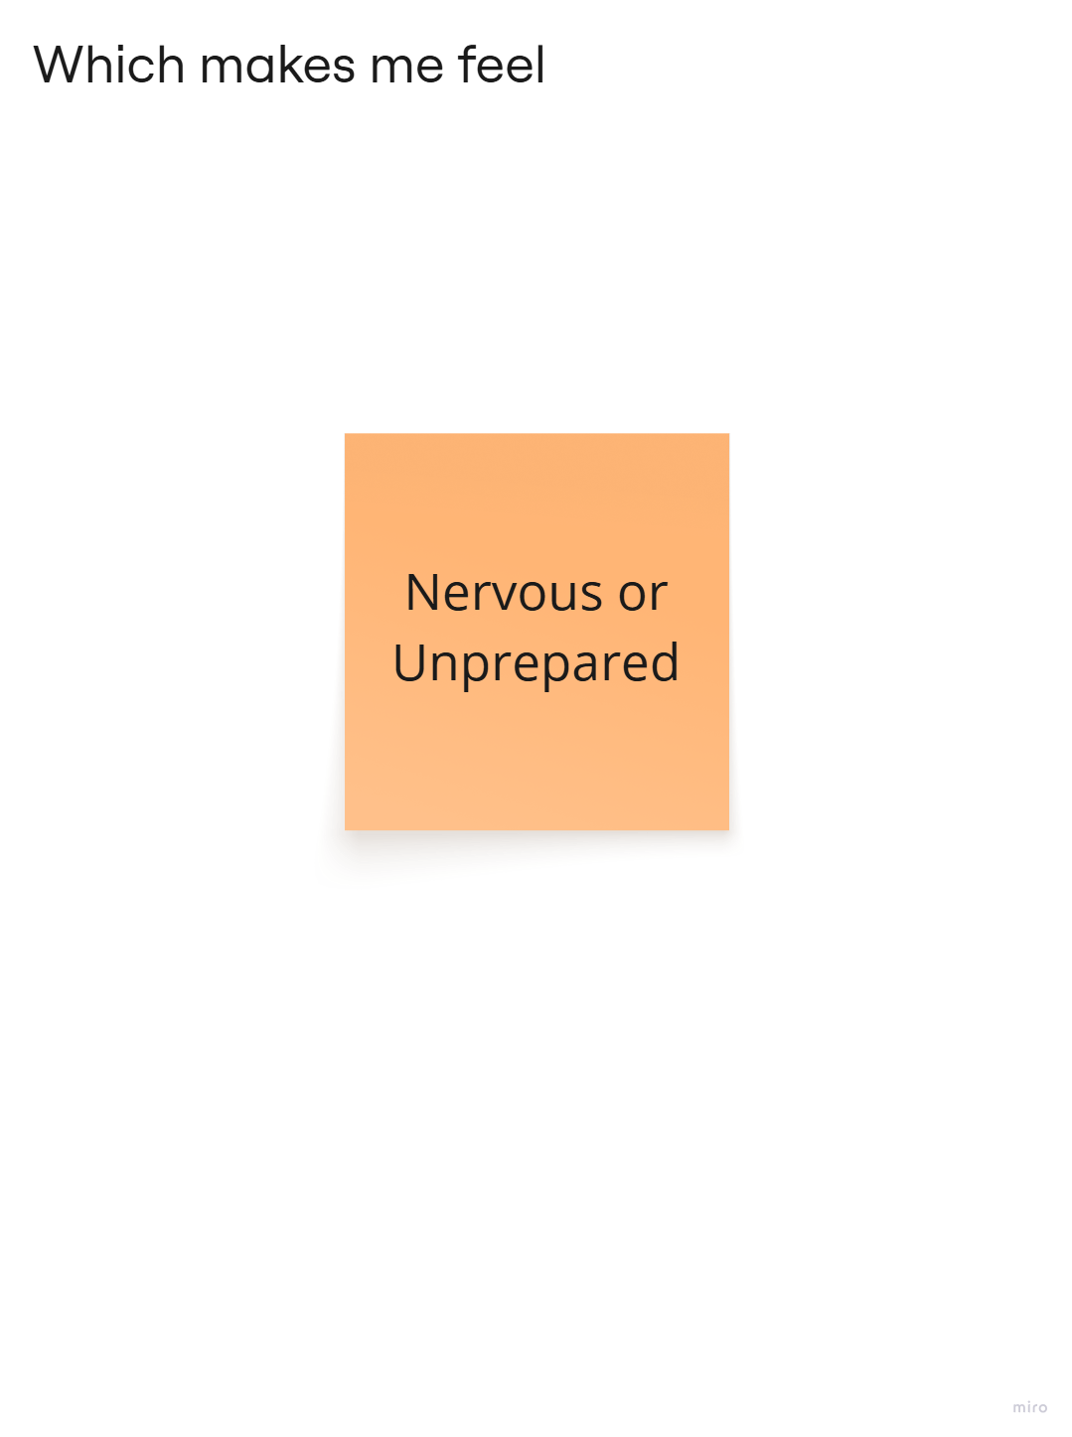

|  |  |  |  |  |  |
| --- | --- | --- | --- | --- | --- |
| **Problem Statement (PS)** | I am (Customer) | I’m trying to | But | Because | Which makes me feel |
| PS-1 | a first-time pageant contestant | prepare confidently for the talent round | I’m confused about the expectations | the guidelines provided are unclear and scattered | Nervous and underprepared |
| PS-2 | an experienced contestant | showcase my personality during interviews | I feel restricted during interactions | the interview format is rigid and lacks openness | Frustrated and unable to express fully |